SWE 574 Software Development as a Team, Fall 2014
Instructor: Suzan Üsküdarlı

WBLH: Web Based Living History Application
System Description Document

04.01.2015
Revision 2.0

By: Eser Gökçe Karaca
Student Id: 2013719078

Revision | Date | Explanation
1.0 | 03.01.2015 | Initial Documentation for System Description
2.0 | 04.01.2015 | Modifications on Section 3  Modifications on Section 5

TABLE of CONTENTS

TABLE of CONTENTS 3
1. INTRODUCTION 4
2. DATA MODEL 4
3. TECHNOLOGY 5
4. ACCESS, AUTHENTICATION and AUTHORISATION 6
5. DELIVERY 6
6. DOCUMENTATION 6

1. INTRODUCTION

This system description document is a documentation describing the technology choices and the environment used in the creation & deployment of Living History application.
Living History application is an application used for entering/viewing/responding to memories. The application has 3 aspects: database, server & client.

2. DATA MODEL

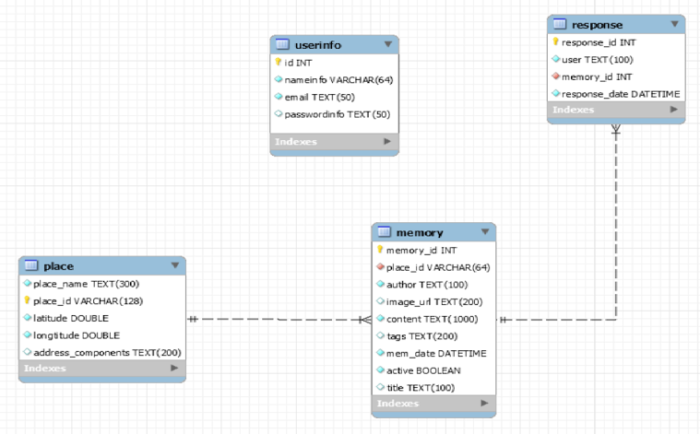

3. TECHNOLOGY

- AngularJS MVC framework Client side code

- GruntJS Front end build tool

- Java Programming language for server side

- MySQL Database implementations

- Heroku Cloud application platform

- Apache TomCat Web server

- Javascript API for Google Maps V3 Visualisation of the maps in application

- Apache Cordova Platform to build mobile applications using web application

code

- JavaScript, HTML Web programming languages

- Node.JS Platform to build server-side/network application

(Used for Android version in this project)

- Eclipse Mars Development tool for server side

- Webstorm 9.0 Development tool for client side

- Google Chrome Developer Tool for debugging on client side

- Apiary Platform for building & consuming Web APIs

- Amazon Web Services Cloud platform with Tomcat & MySQL for testing

- Google Code Google’s web based environment for collaborative code

development projects

- Automated deployment Not available

4. ACCESS, AUTHENTICATION and AUTHORISATION

- The access to the application is Web based.

- Authentication is through a Web form where email address & password information of the user is required.

5. DELIVERY

The application is delivered to the customer in 2 ways:
- CD
- Web Portal given below:
http://ec2-54-72-10-88.eu-west-1.compute.amazonaws.com:8080/LivingHistoryRestService/www/index.html

6. DOCUMENTATION

All detailed documentation regarding the Living History project can be found at Google code pages from the following address:

https://code.google.com/p/living-history-swe/w/list

